**To run the functional prototype, you need to:**

1. Download the code, and open the project folder in Visual Studio Code (or another similar platform). We will select VSCode as example in the following steps.

2. Search and install the Live Server extensions.

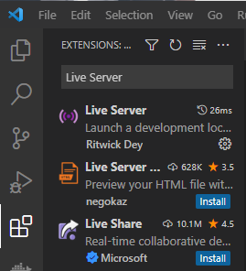

3. Right click the index.html and discussion.html, and select “Open with Live Server”.

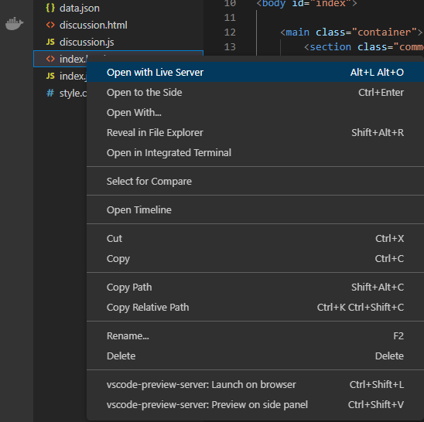

4. Now the project is working and you can check the web browser to try the functions.



